***Disk Schedulling Algorithms***

***1)First Come First Serve***

///Disk Schedulling First In First Out Algorithm

///Adnan Ismail Shah Muzavor

#include<stdio.h>

#include<stdlib.h>

int i;

void FIFO(int n,int ch,int *r,int *e)

{

int HM=0; /// => Head Movements

for(i=0; i<n; i++)

{

if(i==0) HM+=abs(e[i]-ch);

else HM+=abs(e[i]-e[i-1]);

}

printf("\n---------------------------------------------------");

printf("\nBy Disk Schedulling First Come First Serve Algorithm");

printf("\n---------------------------------------------------");

printf("\nNumber of Disk Head Movements : %d",HM);

printf("\n---------------------------------------------------");

}

int main()

{

int n,Current_head;

printf("Enter the number of elements in disk queue: ");

scanf("%d",&n);

int *ele=(int*)malloc(sizeof(int)*n);

printf("\nEnter the elements in disk queue: ");

for(i=0; i<n; i++)

{

scanf("%d",&ele[i]);

}

int *range=(int*)malloc(sizeof(int)*2);

printf("\nEnter the range of cylinder: ");

scanf("%d",&range[0]);

scanf("%d",&range[1]);

printf("\nEnter the position of current head: ");

scanf("%d",&Current_head);

FIFO(n,Current_head,range,ele);

return 1;

}

***Output:***

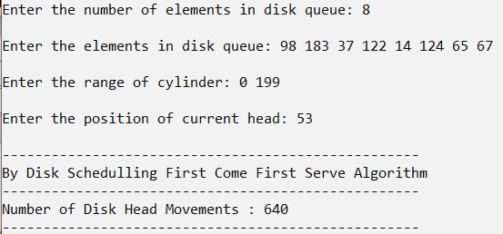

***2)Shortest Seek Time First***

///Disk Schedulling Shortest Seek Time First

///Adnan Ismail Shah Muzavor

#include<stdio.h>

#include<stdlib.h>

#define MAX 1000;

int i;

int Give_nearest(int *vis,int *ele,int n,int from_ele)

{

int index=-1,i;

int min_val=MAX;

for(i=0; i<n; i++)

{

if(!vis[i])

{

if(abs(from_ele-ele[i])<min_val)

{

min_val=abs(from_ele-ele[i]);

index=i;

}

}

}

return index;

}

void SSTF(int n,int ch,int *r,int *e)

{

int HM=0; /// => Head Movements

int *vis=(int*)malloc(sizeof(int)*n);

for(i=0; i<n; i++) vis[i]=0;

for(i=0; i<n; i++)

{

//printf("THe prev ele is: %d",ch);

int index=Give_nearest(vis,e,n,ch);

if(index==-1)

{

printf("\nUnwanted error!!");

break;

}

vis[index]=1;

HM+=abs(e[index]-ch);

ch=e[index];

}

printf("\n--------------------------------------------");

printf("\nBy Disk Schedulling Shortest Seek Time First");

printf("\n--------------------------------------------");

printf("\nNumber of Disk Head Movements : %d",HM);

printf("\n--------------------------------------------");

}

int main()

{

int n,Current_head;

printf("Enter the number of elements in disk queue: ");

scanf("%d",&n);

int *ele=(int*)malloc(sizeof(int)*n);

printf("\nEnter the elements in disk queue: ");

for(i=0; i<n; i++)

{

scanf("%d",&ele[i]);

}

int *range=(int*)malloc(sizeof(int)*2);

printf("\nEnter the range of cylinder: ");

scanf("%d",&range[0]);

scanf("%d",&range[1]);

printf("\nEnter the position of current head: ");

scanf("%d",&Current_head);

SSTF(n,Current_head,range,ele);

return 1;

}

***Output:***

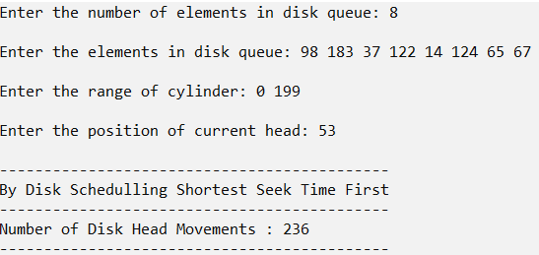

***3)SCAN / ELEVATOR***

///Disk Schedulling SCAN / ELEVATOR

///Adnan Ismail Shah Muzavor

#include<stdio.h>

#include<stdlib.h>

#define MAX 1000;

int i;

int Min_Val(int n,int *ele)

{

int i,min_ele=MAX;

for(i=0; i<n; i++)

{

if(ele[i]<min_ele)

{

min_ele=ele[i];

}

}

return min_ele;

}

int Max_Val(int n,int *ele)

{

int i,max_ele=-1;

for(i=0; i<n; i++)

{

if(ele[i]>max_ele)

{

max_ele=ele[i];

}

}

return max_ele;

}

void SCAN(int n,int ch,int d,int *range,int *e)

{

int HM=0; /// => Head Movements

int *vis=(int*)malloc(sizeof(int)*n);

for(i=0; i<n; i++) vis[i]=0;

if(d==1)

{

printf("\n--------------------------------------------");

printf("\nDisk Direction is Towards Left");

HM=abs(range[0]-ch);

HM+=abs(range[0]-Max_Val(n,e));

}

else

{

printf("\n--------------------------------------------");

printf("\nDisk Direction is Towards Right");

HM=abs(range[1]-ch);

HM+=abs(range[1]-Min_Val(n,e));

}

printf("\n--------------------------------------------");

printf("\nBy Disk Schedulling SCAN / ELEVATOR");

printf("\n--------------------------------------------");

printf("\nNumber of Disk Head Movements : %d",HM);

printf("\n--------------------------------------------");

}

int main()

{

int n,Current_head,d;

printf("Enter the number of elements in disk queue: ");

scanf("%d",&n);

int *ele=(int*)malloc(sizeof(int)*n);

printf("\nEnter the elements in disk queue: ");

for(i=0; i<n; i++)

{

scanf("%d",&ele[i]);

}

int *range=(int*)malloc(sizeof(int)*2);

printf("\nEnter the range of cylinder: ");

scanf("%d",&range[0]);

scanf("%d",&range[1]);

printf("\nEnter the position of current head: ");

scanf("%d",&Current_head);

printf("\nEnter the direction of disk movement (1)=>Left, (2)=>Right: ");

scanf("%d",&d);

SCAN(n,Current_head,d,range,ele);

return 1;

}

***Output:***

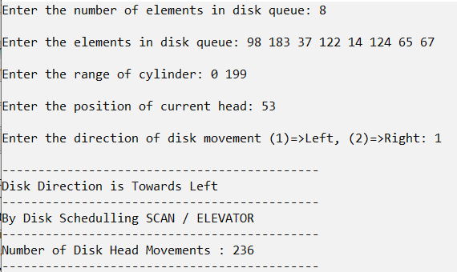

***4)C-SCAN***

///Disk Schedulling C-SCAN

///Adnan Ismail Shah Muzavor

#include<stdio.h>

#include<stdlib.h>

#define MAX 1000;

int i;

int Next_Right_Val_From_CH(int n,int ch,int *ele)

{

int val=-1,min_diff=MAX;

for(i=0; i<n; i++)

{

if(ele[i]>=ch && abs(ele[i]-ch)<min_diff)

{

val=ele[i];

min_diff=abs(ele[i]-ch);

}

}

return val;

}

int Prev_Left_Val_From_CH(int n,int ch,int *ele)

{

int val=-1,min_diff=MAX;

for(i=0; i<n; i++)

{

if(ele[i]<=ch && abs(ele[i]-ch)<min_diff)

{

val=ele[i];

min_diff=abs(ele[i]-ch);

}

}

return val;

}

void SCAN(int n,int ch,int d,int *range,int *e)

{

int HM=0; /// => Head Movements

int *vis=(int*)malloc(sizeof(int)*n);

for(i=0; i<n; i++) vis[i]=0;

if(d==1)

{

printf("\n--------------------------------------------");

printf("\nDisk Direction is Towards Left");

HM=abs(range[0]-ch);

HM+=abs(range[0]-range[1]);

HM+=abs(range[1]-Next_Right_Val_From_CH(n,ch,e));

}

else

{

printf("\n--------------------------------------------");

printf("\nDisk Direction is Towards Right");

HM=abs(range[1]-ch);

HM+=abs(range[0]-range[1]);

HM+=abs(range[0]-Prev_Left_Val_From_CH(n,ch,e));

}

printf("\n--------------------------------------------");

printf("\nBy Disk Schedulling C-Scan Algorithm");

printf("\n--------------------------------------------");

printf("\nNumber of Disk Head Movements : %d",HM);

printf("\n--------------------------------------------");

}

int main()

{

int n,Current_head,d;

printf("Enter the number of elements in disk queue: ");

scanf("%d",&n);

int *ele=(int*)malloc(sizeof(int)*n);

printf("\nEnter the elements in disk queue: ");

for(i=0; i<n; i++)

{

scanf("%d",&ele[i]);

}

int *range=(int*)malloc(sizeof(int)*2);

printf("\nEnter the range of cylinder: ");

scanf("%d",&range[0]);

scanf("%d",&range[1]);

printf("\nEnter the position of current head: ");

scanf("%d",&Current_head);

printf("\nEnter the direction of disk movement (1)=>Left, (2)=>Right: ");

scanf("%d",&d);

SCAN(n,Current_head,d,range,ele);

return 1;

}

***Output:***

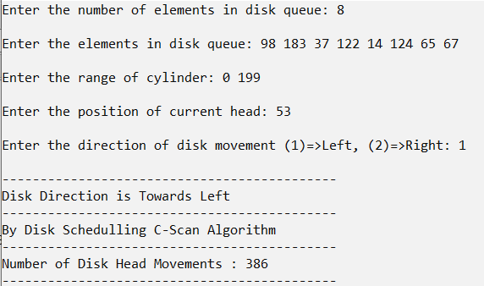

***5)LOOK***

///Disk Schedulling Look Algorithm

///Adnan Ismail Shah Muzavor

#include<stdio.h>

#include<stdlib.h>

#define MAX 1000;

int i;

int Min_Val(int n,int *ele)

{

int i,min_ele=MAX;

for(i=0; i<n; i++)

{

if(ele[i]<min_ele)

{

min_ele=ele[i];

}

}

return min_ele;

}

int Max_Val(int n,int *ele)

{

int i,max_ele=-1;

for(i=0; i<n; i++)

{

if(ele[i]>max_ele)

{

max_ele=ele[i];

}

}

return max_ele;

}

void SCAN(int n,int ch,int d,int *range,int *e)

{

int HM=0; /// => Head Movements

int *vis=(int*)malloc(sizeof(int)*n);

for(i=0; i<n; i++) vis[i]=0;

if(d==1)

{

printf("\n--------------------------------------------");

printf("\nDisk Direction is Towards Left");

HM=abs(Min_Val(n,e)-ch);

HM+=abs(Min_Val(n,e)-Max_Val(n,e));

}

else

{

printf("\n--------------------------------------------");

printf("\nDisk Direction is Towards Right");

HM=abs(Max_Val(n,e)-ch);

HM+=abs(Max_Val(n,e)-Min_Val(n,e));

}

printf("\n--------------------------------------------");

printf("\nBy Disk Schedulling Look Algorithm");

printf("\n--------------------------------------------");

printf("\nNumber of Disk Head Movements : %d",HM);

printf("\n--------------------------------------------");

}

int main()

{

int n,Current_head,d;

printf("Enter the number of elements in disk queue: ");

scanf("%d",&n);

int *ele=(int*)malloc(sizeof(int)*n);

printf("\nEnter the elements in disk queue: ");

for(i=0; i<n; i++)

{

scanf("%d",&ele[i]);

}

int *range=(int*)malloc(sizeof(int)*2);

printf("\nEnter the range of cylinder: ");

scanf("%d",&range[0]);

scanf("%d",&range[1]);

printf("\nEnter the position of current head: ");

scanf("%d",&Current_head);

printf("\nEnter the direction of disk movement (1)=>Left, (2)=>Right: ");

scanf("%d",&d);

SCAN(n,Current_head,d,range,ele);

return 1;

}

***Output:***

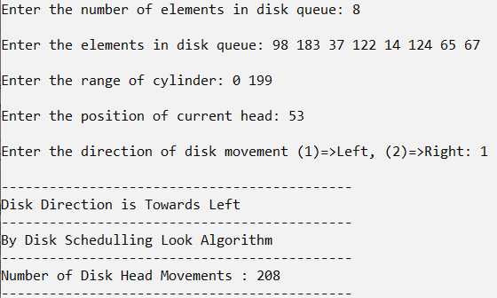

***6)C-LOOK***

///Disk Schedulling C-Look

///Adnan Ismail Shah Muzavor

#include<stdio.h>

#include<stdlib.h>

#define MAX 1000;

int i;

int Min_Val(int n,int *ele)

{

int i,min_ele=MAX;

for(i=0; i<n; i++)

{

if(ele[i]<min_ele)

{

min_ele=ele[i];

}

}

return min_ele;

}

int Max_Val(int n,int *ele)

{

int i,max_ele=-1;

for(i=0; i<n; i++)

{

if(ele[i]>max_ele)

{

max_ele=ele[i];

}

}

return max_ele;

}

int Prev_Left_Val_From_CH(int n,int ch,int *ele)

{

int val=-1,min_diff=MAX;

for(i=0; i<n; i++)

{

if(ele[i]<=ch && abs(ele[i]-ch)<min_diff)

{

val=ele[i];

min_diff=abs(ele[i]-ch);

}

}

return val;

}

int Next_Right_Val_From_CH(int n,int ch,int *ele)

{

int val=-1,min_diff=MAX;

for(i=0; i<n; i++)

{

if(ele[i]>=ch && abs(ele[i]-ch)<min_diff)

{

val=ele[i];

min_diff=abs(ele[i]-ch);

}

}

return val;

}

void SCAN(int n,int ch,int d,int *range,int *e)

{

int HM=0; /// => Head Movements

int *vis=(int*)malloc(sizeof(int)*n);

for(i=0; i<n; i++)

vis[i]=0;

if(d==1)

{

printf("\n--------------------------------------------");

printf("\nDisk Direction is Towards Left");

HM=abs(Min_Val(n,e)-ch);

HM+=abs(Min_Val(n,e)-Max_Val(n,e));

HM+=abs(Max_Val(n,e)-Next_Right_Val_From_CH(n,ch,e));

}

else

{

printf("\n--------------------------------------------");

printf("\nDisk Direction is Towards Right");

HM=abs(Max_Val(n,e)-ch);

HM+=abs(Max_Val(n,e)-Min_Val(n,e));

HM+=abs(Min_Val(n,e)-Prev_Left_Val_From_CH(n,ch,e));

}

printf("\n--------------------------------------------");

printf("\nBy Disk Schedulling C-Look Algorithm");

printf("\n--------------------------------------------");

printf("\nNumber of Disk Head Movements : %d",HM);

printf("\n--------------------------------------------");

}

int main()

{

int n,Current_head,d;

printf("Enter the number of elements in disk queue: ");

scanf("%d",&n);

int *ele=(int*)malloc(sizeof(int)*n);

printf("\nEnter the elements in disk queue: ");

for(i=0; i<n; i++)

{

scanf("%d",&ele[i]);

}

int *range=(int*)malloc(sizeof(int)*2);

printf("\nEnter the range of cylinder: ");

scanf("%d",&range[0]);

scanf("%d",&range[1]);

printf("\nEnter the position of current head: ");

scanf("%d",&Current_head);

printf("\nEnter the direction of disk movement (1)=>Left, (2)=>Right: ");

scanf("%d",&d);

SCAN(n,Current_head,d,range,ele);

return 1;

}

***Output:***

